Overview of VC707 Evaluation Board

During the internship, I have been using VC707 evaluation board which provides a hardware environment or developing and evaluating designs targeting Virtex-7 XC7Vx485T-2FFG1761C FPGA.

Some features of VC707 evaluation board are listed below.

* Clock Generation:
  + Fixed 200 MHz LVDS oscillator (Differential)
  + I2C Programmable LVDS oscillator (Differential)
  + SMA connector (Differential)
  + SMA connector for GTX transceiver (Differential)
  + Also 25 MHz clock is available for Ethernet PHY
* User I/O
  + 8 User LEDs
  + 5 User Push Buttons
  + 8-pole DIP Switches
  + One pair of User SMA GPIO Connectors
  + 16x2 Character LCD
* PMBus voltage and current monitoring through TI power controller
* HDMI CODEC
* 10/100/1000 tri-speed Ethernet PHY
* SFP+ Connector
* PCI Express endpoint connectivity
* VITA 57.1 FMC1/2 HPC Connector
* 1 GB DDR3 memory SODIMM
* 128 MB BPI Flash memory

Block Diagram of the Board is shown below.

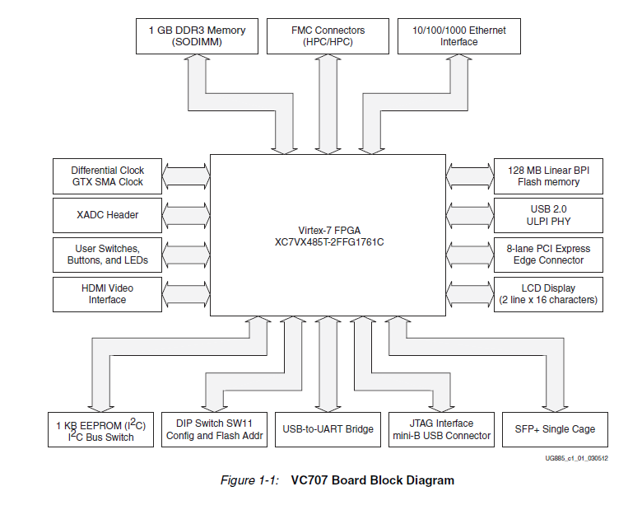

FPGA Configuration:

Before using the FPGA board, configuration switches must be set. There are two configuration modes of the VC707 which are Master BPI and JTAG. Configuration switches and modes are shown below.

